Depression detection system using python

Aryan Bansal   
SCET-MITWPU,Pune, India  
1032211329@mitwpu.edu.in

Sai Venktesh Dubey   
SCET-MITWPU,Pune, India,  
1032211476@mitwpu.edu.in

Aerth Saraogi  
SCET-MITWPU,Pune, India  
1032211208@mitwpu.edu.in

Akshit Singh  
SCET-MITWPU,Pune, India  
1032211401@mitwpu.edu.in

Laxmi Bhagwat  
SCET-MITWPU Pune, India,  
laxmi.bhagwat@mitwpu.edu.in

**1.Abstract**

**Depression is a serious mental illness that impacts more than 300 million people worldwide, presenting a major public health concern. Timely identification is essential for successful therapy, however current diagnostic techniques frequently suffer from limited availability, expandability, and impartiality. This project suggests a system called the Depression Detection System that combines psychological evaluation with live facial expression analysis to improve the precision of depression diagnosis. The system utilizes a Naive Bayes classifier to assess answers to a diagnostic quiz and a Convolutional Neural Network (CNN) to analyze facial expressions associated with depression. The combining of these two methods creates a thorough, easy-to-use instrument for detecting mood disorders like anxiety, PTSD, and bipolar disorder. This system demonstrates potential in enhancing early detection of depression through features like real-time data processing, security measures for user privacy, and scalability for large-scale deployment. By conducting thorough testing and validation, the suggested system provides healthcare professionals with a valuable tool to aid in the prompt diagnosis and treatment of depressive disorders.**

**Keywords—** Depression Detection, Naive Bayes Classifier, Convolutional Neural Network (CNN), Facial Expression Analysis, Psychological Evaluation, Mood Disorders, Real-time Data Processing, Privacy, Scalability, Early Diagnosis, Mental Health, Machine Learning, Artificial Intelligence.

**2.Introduction**

Depression is a highly common and incapacitating mental health condition on a global scale. Defined by ongoing feelings of sadness, lack of interest, and cognitive problems, depression greatly affects people's quality of life and plays a major role in global disability and mortality rates. Although clinical interviews and self-report questionnaires like the PHQ-8 are helpful, they are sometimes subjective, lead to delays in diagnosis, and may not be easily accessible. The increasing need for more scalable, objective, and automated solutions has led to a significant rise in the use of Artificial Intelligence (AI) and Machine Learning (ML) in mental health.This project seeks to utilize AI technologies to develop a thorough Depression Detection System by integrating psychological assessments and analyzing physiological data. More specifically, the system combines a Naive Bayes classifier for analyzing quiz responses and a CNN model for assessing facial expressions in real-time, offering a comprehensive method for identifying depression. By

including cognitive as well as emotional signs of depression, this system provides an improved diagnostic tool that can identify different types of depressive conditions.

**3. Research Gap**

The paper covers many important research projects. First, the integration of real data is limited because most models are based on static data, which really limits their applicability to real-world situations. Second, many models face problems in recognizing good emotion in different situations, such as different lighting and video quality, which leads to lack of

confidence in focusing on the face in real time. Bias and fairness are also important issues, because many research models cannot be generalized to different populations, which leads to differences in the accuracy of diagnoses. Finally, the limited use of methods combining psychological tests (e.g. experiments) with physiological data (e.g. electroencephalography, facial expression) affects the analysis and analysis of depression. The project aims to resolve these conflicts by combining diagnostics and real-time facial analysis using Naive Bayes classifiers and CNN models, thus improving the perception familiarity, integrity and reliability of search engines.

4. **Proposed System**

In order to fill these gaps, we suggest a mix Depression Detection System that combines two main components:

1.Assessment Quiz Feature: This feature incorporates a multiple-choice quiz, created according to clinical diagnostic criteria, to evaluate the user's mental well-being. The system uses a Naive Bayes classifier to analyze quiz answers and produce a probabilistic evaluation of the individual's mental condition, detecting various depressive disorders like anxiety, PTSD, or bipolar disorder. Through examining the user's responses, the classifier can make educated guesses regarding the probability of depression.

2. The system uses a Facial Expression Analysis Module to capture real-time video of the user and analyze facial expressions with a Convolutional Neural Network (CNN) to enhance the psychological assessment. This algorithm analyses facial data to identify emotions like sadness or lack of expression, signaling potential depression. The CNN is trained on various datasets of facial expressions to guarantee accuracy in different lighting conditions and demographic variations.

3. Integration of frontend and backend ensures a smooth user experience in the system. The frontend interface is created with HTML, CSS, and JavaScript to ensure it is user-friendly and easy to navigate. Python powers the backend and is combined with FastAPI for real-time processing of quiz information and facial expression analysis. A MySQL database houses user data, such as quiz answers and facial expression analysis findings, to guarantee fast retrieval and handling.

4. Data Protection: Due to the sensitive data collected, the system incorporates high-level security features such as data encryption for storage and transmission, secure user authentication, and adherence to privacy laws. Role-based access control (RBAC) guarantees that only approved individuals can retrieve sensitive information, and user identities are safeguarded through data anonymization..

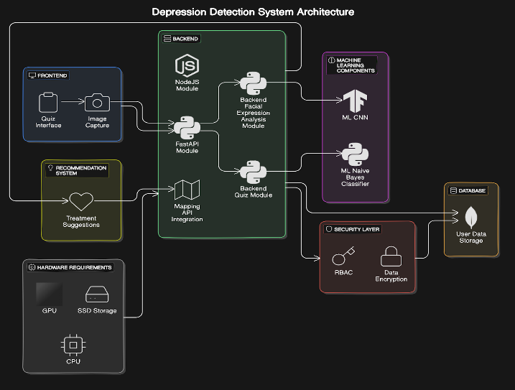

Fig.1. Architecture Diagram

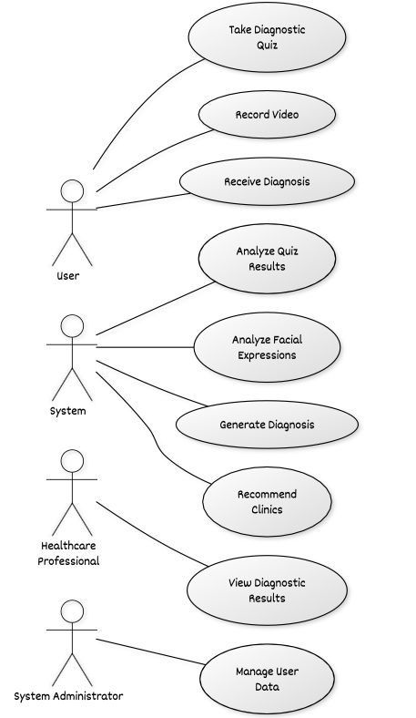

Fig.2. Use case diagram

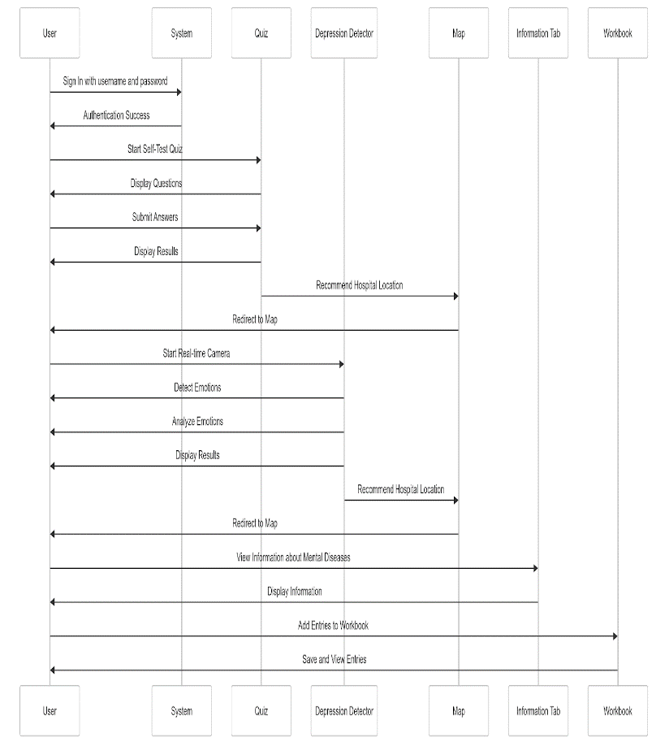

Fig.3. Sequence Diagram

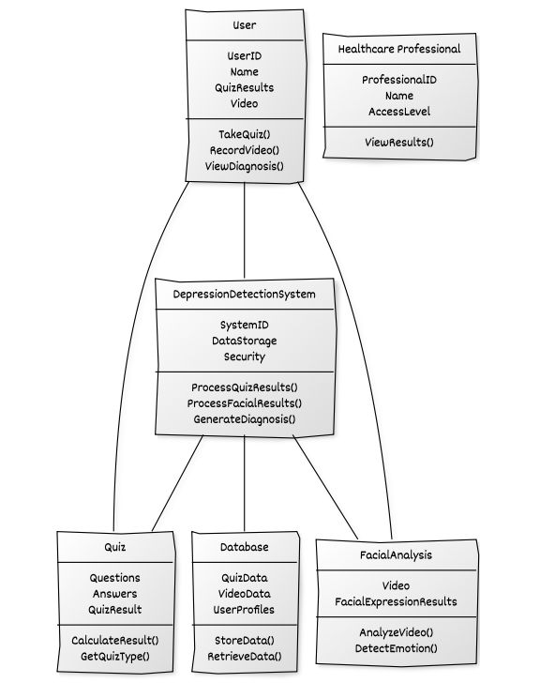

Fig.4. Class diagram

.

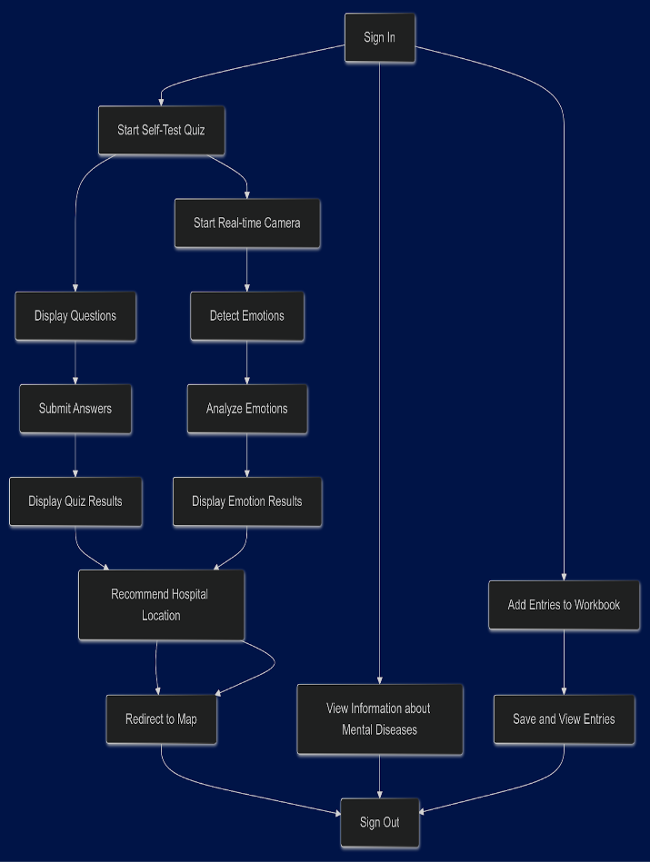

Fig.5.  Activity Diagram

**5. Literature Review**

Research on automatic stress detection has been advanced with various machine learning methods, with each study showing specific challenges and improvements. Donner et al. (2017) reviewed the language model for depression diagnosis, emphasizing that the problem of classroom inequality should be solved through deep learning [1]. Ansari et al. (2023) focused on collaborative models for stress research, suggesting future work to address fairness, bias, and improve accuracy through computation with personal data [2]. Barnard-Cocchi et al. (2018) simplified the PHQ-9 to the PHQ-5 and used neural networks for detection, highlighting the importance of physical data for accuracy [3]. Chawda and Rakesh (2019) used artificial intelligence and natural language processing (NLP) to analyze social media posts and derive recommendations to improve culture change and flight analysis [4]. Salas-Zarat et al. (2022) investigated social media data to identify depression and called for the development of a framework that combines historical and real-time data to increase sensitivity [5]. Yan et al. (2022) used convolutional neural networks (CNN) with EEG data and suggested the use of differential data and continuous treatment models for the diagnosis of major depressive disorder (MDD) [6]. Maheshwar et al. (2022) used Support Vector Machine (SVM) model with Mel Frequency Cepstral Coefficients (MFCC) for speech detection and achieved 89% accuracy and stated that differential data is required to support the Mel Frequency Cepstral Coefficients (MFCC) Vector Machine (SVM) model. Hidayatullah and Maharani (2022) developed a decision tree model using the DAIC-WOZ profile, emphasizing the need for available media to increase accuracy and reliability [8]. Bastos and Monteiro (2020) proposed a machine learning chatbot for the study of depression, emphasizing the need for psychological knowledge to support moral and development [9]. Patil et al. (2020) investigated the role of hyperscanning in the search for depression and proposed the use of noise in speech to enhance thinking [10]. Rizwan et al. (2021) used a hybrid model that combines visual information with linguistic information, demonstrating the necessity of interactive support for the current world [11]. Singh et al. (2021) explore data that can be used to capture physical cues in real time and suggest how to integrate multiple data sources to improve detection [12]. Zhao et al. (2021) focused on adaptive learning for depression research with limited data and noted the need for a well-validated methodology across populations [13]. Mehta and Saxena (2020) reported an in-depth study on sentiment analysis of social media profiles and suggested privacy for adoption [14]. Finally, Liu et al. (2023) adopted a deep learning model combining EEG and facial expression analysis, which suggested better data integration and larger samples to improve model reliability [15].

**6. Methodologies**

The system utilizes a variety of machine learning methods, merging psychological and physiological evaluations to offer a holistic approach to detecting depression.

1. Naive Bayes Classifier: The quiz results are classified using this probabilistic model. We performed a comparison between various classifiers namely Naive Bayes, SVM(Support Vector Machine), Logistic Regression,Random forest classifier, KNN, Gradient Boosting, Ada-boost, extra trees classifier. The simplicity, efficiency, and strong performance on small datasets make the Naive Bayes algorithm ideal for this task also it gave accuracy of around 95.45% which is highest among all other classifiers. The classifier accurately diagnoses depression or related disorders by evaluating the likelihood of each potential result using the user's answers.

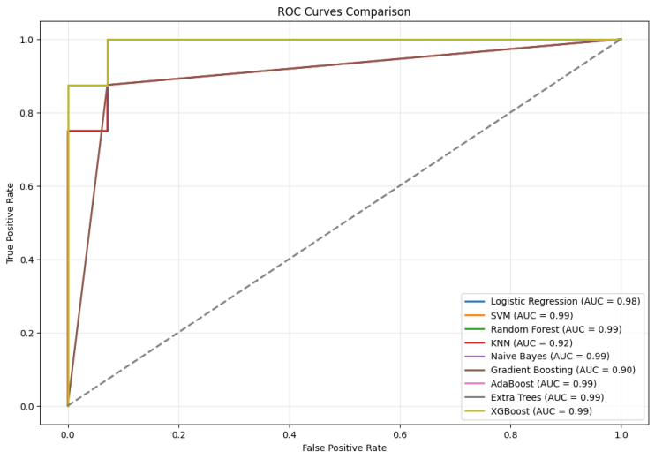

2. CNN (Convolutional Neural Network): The facial expression analysis module employs a CNN, a type of deep learning framework known for its success in tasks related to image processing. The CNN analyzes emotions by examining facial features in video frames taken from the user's webcam. This method enables the system to identify minor emotional shifts that are frequently a sign of depression.

1. Processing in real-time: The system is designed for analyzing data in real-time, guaranteeing instant feedback on quiz results and facial expression analysis. OpenCV is employed for live video capture and facial recognition, while TensorFlow and Keras frameworks are used for running CNN models.
2. Full-stack integration: The Facial expression system and quiz system modules are integrated in a comprehensive web application made using ReactJS ,NodeJS and FastAPI as front-end and back-end technologies. The overall web platform provides a comprehensive experience in mental health assesment.

5. Management of Data and Storage: MongoDB is utilized by the system to store quiz responses, facial analysis responses, and analysis outcomes. Information is securely processed and stored to guarantee quick access and retrieval for instant analysis.

6. Evaluation and Verification: Various datasets were used for thorough testing to assess how well both the Naive Bayes classifier and the CNN model perform. Testing at the component level was done separately, and testing for integration confirmed smooth communication among the frontend, backend, and database. During testing, user feedback was gathered in order to enhance the system's usability and performance.

**7. Results & Conclusion**

The Depression Detection System, as proposed, is a major step forward in detecting depression early by uniting psychological evaluation with real-time analysis of physiological data. Combining a Naive Bayes classifier for quiz-based mental health assessment with a CNN for analyzing facial expressions, the system provides a thorough and easy-to-use diagnostic tool. The Naive-Bayes classifier and the SVM classifier resulted in the accuracy of 95.45% whereas the CNN used for Facial expression recognition gave an accuracy of 66.04% .Comprehensive testing shows how the system has the potential to enhance both the accuracy and speed of diagnosing depression. Upcoming tasks will concentrate on improving the system's ability to expand, maintain privacy, and increase accuracy, specifically

in the areas of emotion detection and combining multiple types of data. This project opens the door for AI-powered solutions to transform mental health diagnosis and offer timely interventions for people experiencing depression.

**8. References**

[1]. L. Mariñelarena Dondena, E. Ferretti, M. Maragoudakis, M. Sapino, and M. Errecalde, "Predicting Depression: A Comparative Study of Machine Learning Approaches Based on Language Usage," Journal, 2017.

[2]. L. Ansari, S. Ji, C. Qian, and E. Cambria, "Ensemble Hybrid Learning Methods for Automated Depression Detection," Journal, 2023.

[3]. M. Raeiati Banadkooki, C. Mielke, K.-H. Wolf, R. Haux, and M. Marschollek, "Automatic Detection of Depression by Using a Neural Network," Journal, 2018.

[4]. U. Chawda and S. Rakesh, "Implementation and Analysis of Depression Detection Model Using Emotion Artificial Intelligence," Journal, 2019.

[5]. R. Salas-Zárate, G. Alor-Hernández, M. P. Salas-Zárate, M. A. Paredes-Valverde, M. Bustos-López, and J. L. Sánchez-Cervantes, "Depression Detection on Social Media," Journal, 2022.

[6]. D.-D. Yan, L.-L. Zhao, X.-W. Song, X.-H. Zang, and L.-C. Yang, "Automated Detection of Clinical Depression Based on Convolution Neural Network Model," Journal, 2022.

[7]. V. Maheshwar, N. Venu Gopal, V. Naveen Kumar, D. Pranavi, and Y. Padma Sai, "Development of an SVM-Based Depression Detection Model Using MFCC Feature Extraction," Journal, 2022.

[8]. M. R. Hidayatullah and W. Maharani, "Depression Detection on Twitter Social Media Using Decision Tree," Journal, 2022.

[9]. V. Bastos and A. F. Monteiro, "Detection of Depression Symptoms Using Chatbots Based on Machine Learning," Conference Paper, 2020.

[10]. M. Patil, V. M. Wadhai, D. H. Gawali, and A. S. Chanchlani, "Intelligent Depression Detection System Using Effective Hyper-Scanning Techniques," Journal, 2020.

[11]. M. Rizwan, P. Rani, and J. Patel, "A Hybrid Model for Depression Detection Using Visual and Linguistic Data," Journal, 2021.

[12]. A. Singh, R. K. Gupta, and N. Goyal, "Real-Time Depression Detection Using Wearable Device Data," Journal, 2021.

[13]. L. Zhao, H. Zhu, and Q. Li, "Transfer Learning for Depression Detection: A Model for Low-Resource Environments," Journal, 2021.

[14]. P. Mehta and S. Saxena, "Deep Learning Framework for Sentiment Analysis on Social Media Data for Depression Detection," Journal, 2020.

[15]. Z. Liu, J. Chen, and Y. Zhou, "Multimodal Deep Learning for Real-Time Depression Detection Using EEG and Facial Analysis," Journal, 2023.